

PANGANI GIRLS’ KCSE PREDICTION
EXAM TEST-2025
231/2
BIOLOGY
THEORY
PAPER 2
TIME: 2 HOURS

NAME…………………………………………………………………………………………
SCHOOL………………………………………………. SIGN……………………..
INDEX NO ……………………………………………. DATE…………………….

Kenya Certificate of Secondary Education.

INSTRUCTIONS TO CANDIDATES
- This paper consists of two sections A and B.
- Answer ALL questions in section A
- Answer question 6 (compulsory) and either question 7 or 8 in section B.

FOR EXAMINER’S USE ONLY
Section | Question | Maximum score | Candidate’s score
A | 1  2  3  4  5 | 8  8  8  8  8
B | 6  7  8 | 20  20  20
Total Marks |  | 80

SECTION A (40 MARKS)
Answer all questions in this section.
1. The diagram below shows a cross section through the female part of a flower.
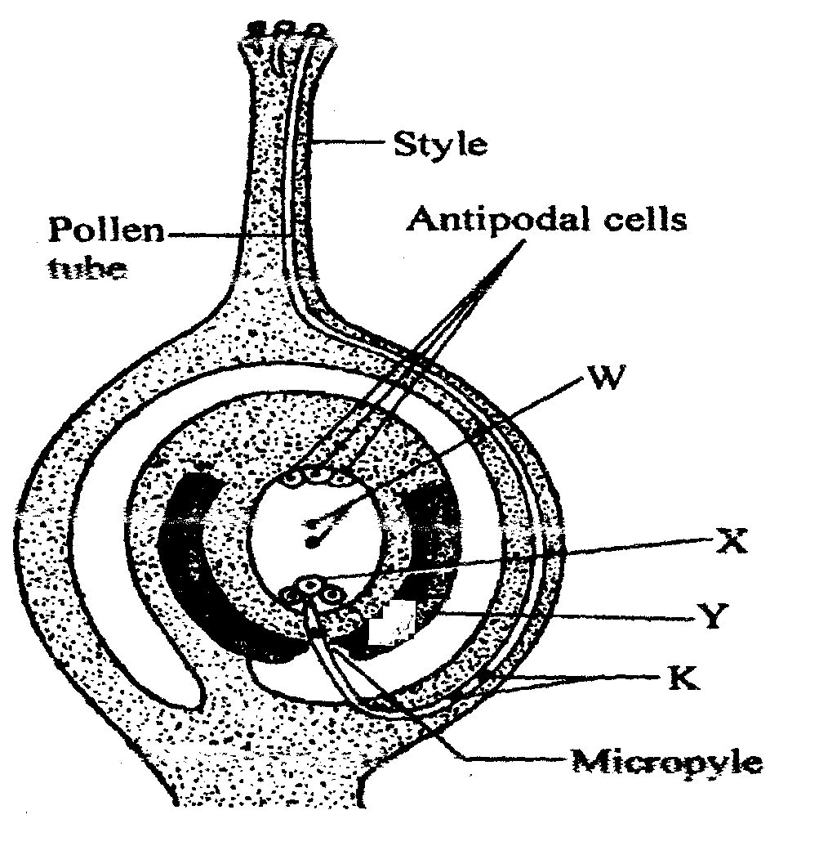
a) Name the structures labeled W,X, and Y. (3mks)
W ......................................................................................
X ......................................................................................
Y ......................................................................................
b) State two functions of the pollen tube. (2mks)
……………………………………………………………………………………………………
……………………………………………………………………………………………………

c) What happens to antipodal cells after fertilization. (1mk)
……………………………………………………………………………………………………
……………………………………………………………………………………………………

d) Name the structure labeled K and state their role. (2mks)
……………………………………………………………………………………………………
……………………………………………………………………………………………………
……………………………………………………………………………………………………

- The diagram below illustrates and experiment to determine the rate of respiration in a small insect.
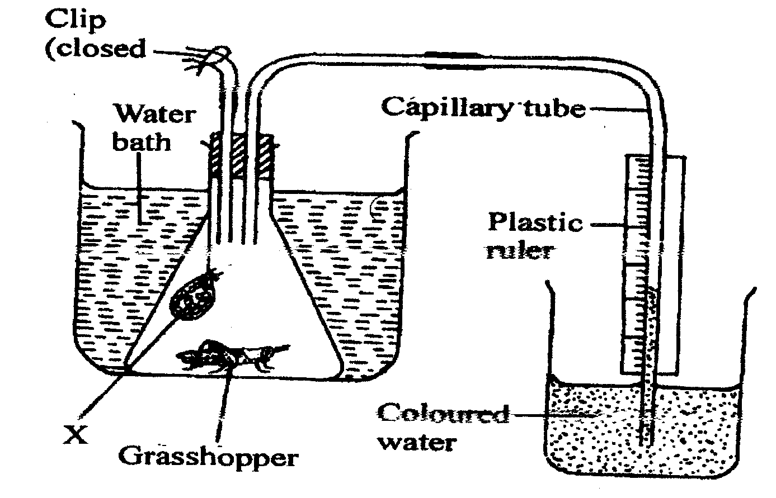

a) Name the chemical compound labeled X and state its function. (2mks)
……………………………………………………………………………………………………
……………………………………………………………………………………………………

b) Why is it necessary to place the flask in a water bath. (3mks)
……………………………………………………………………………………………………
……………………………………………………………………………………………………
……………………………………………………………………………………………………
……………………………………………………………………………………………………
……………………………………………………………………………………………………

c) What changes would you expect to observe in the level of coloured water in the capillary tube after the experiment has run for five minutes. (1mk)
……………………………………………………………………………………………………
……………………………………………………………………………………………………
……………………………………………………………………………………………………

d) Explain the changes you have started in (c) above. (3mks)
……………………………………………………………………………………………………
……………………………………………………………………………………………………
……………………………………………………………………………………………………

e) State how you can set up a control experiment . (1mk)
……………………………………………………………………………………………………
……………………………………………………………………………………………………

3. The diagram below shows some components of a light microscope.
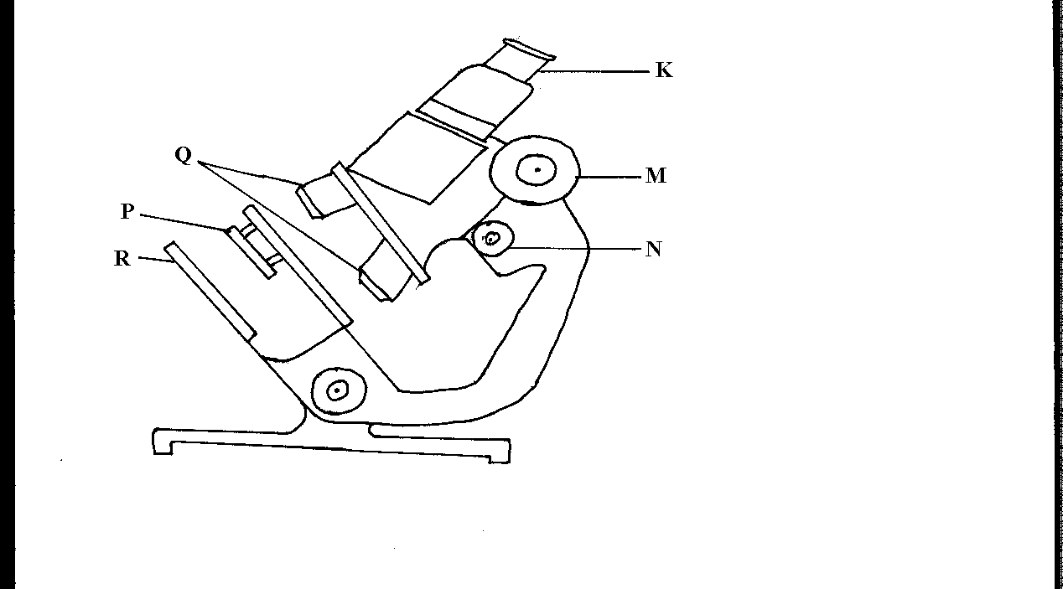

- Name the parts labeled (2mrks)
K…………………………………………………………………………………………
M…………………………………………………………………………………………

- State the functions of (2mrks)
P…………………………………………………………………………………………
Q…………………………………………………………………………………………

- A student was viewing a prepared slide of a plant cell under high power microscope. The features of the cell were blurred. Which one of the labeled parts of the microscope would the student use to obtain:-
- a sharper outline of the features. (1mrk)
……………………………………………………………………………………………………

- Give the formula used to calculate magnification in a light microscope. (1mrk)
……………………………………………………………………………………………………
……………………………………………………………………………………………………
……………………………………………………………………………………………………

- A student was preparing a section of a plant cell to be viewed on a light microscope. Give a reason for each of the following steps:-
(i)Cutting a very thin section (1mrk)
……………………………………………………………………………………………………
……………………………………………………………………………………………………

(ii)Staining the section (1mrk)
……………………………………………………………………………………………………
……………………………………………………………………………………………………

(iii)Putting the section in water (1mrk)
……………………………………………………………………………………………………
……………………………………………………………………………………………………

4. In an experiment, a black mouse was mated with a brown mouse; all the off-springs were
black. The off-springs grew and were allowed to mate with one another. The total number
of (F2) generation off-springs was 96.
- Using the letter symbols capital letter B for the gene of black colour and small b for brown colour, Work out the genotype of the F1 generation. (3mrks)

b) From the information above, work out the following for the F2 generation.
i) Genotypic ratio. (2mrks)
……………………………………………………………………………………………………
……………………………………………………………………………………………………
……………………………………………………………………………………………………
……………………………………………………………………………………………………

ii) Phenotypic ratio. (1mrk)
……………………………………………………………………………………………………
……………………………………………………………………………………………………

iiii) The total number of brown mice (2mrks)
……………………………………………………………………………………………………
……………………………………………………………………………………………………
……………………………………………………………………………………………………
……………………………………………………………………………………………………
5. In a physiological experiment, starch, protein, diastase and sodium chloride were added to water and put inside a visking tubing. The visking tubing was then placed in a water bath maintained at a temperature between 35 --- 40°C. The set up was as shown in the diagram below.
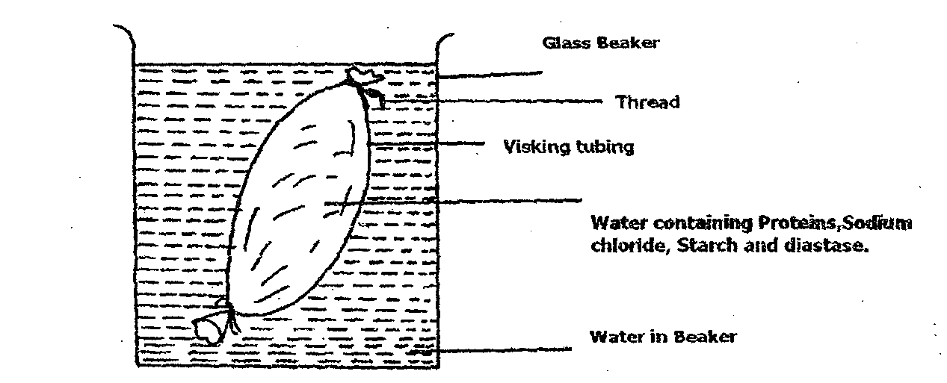
The following observations were made after the procedures indicated.
Contents in | At the start of experiment | After 1 hour
Visking tubing | i) Solution tastes salty | Solution tastes salty
 | ii) Visking tubing is not firm | Visking tubing is firm
 | iii) After boiling with Benedicts  solution, solution remains blue | After boiling with Benedicts solution the solution turns brown
 | iv) On addition of solution  hydroxide followed by copper  sulphate solution to the solution,  the colour changes to purple | On addition of sodium hydroxide followed by coppers sulphate to the solution, the colour changes to purple
Beaker | i) Water is tasteless | Solution tastes sweet/salty
 | ii) After boiling solution with  Benedicts solution, Blue colour  remains | After boiling solution with Benedicts solution, colour turns to brown
 | iii) On addition to sodium hydroxide  followed by copper sulphate solution,  colour remains blue | On addition of sodium hydroxide followed by copper sulphate solution, colour remains blue

- Name the process by which salt moved into the water in the beaker from the visking tubing. (1mark)
……………………………………………………………………………………………………
b) i) Name the food substance responsible for the brown colour observed after 1 hour
both in the beaker and visking tubing when solutions are boiled with benedicts solution. (l mk)
……………………………………………………………………………………………………
ii) Account for the observation in (b i) above. (3 marks)
……………………………………………………………………………………………………
……………………………………………………………………………………………………
……………………………………………………………………………………………………
……………………………………………………………………………………………………

c) i) Name the food substance tested with sodium hydroxide followed by copper sulphate solution(s) (1 mark)
……………………………………………………………………………………………………
ii) Account for the absence of the food substance named in (c i) above in the beaker after 1 hour. (l mark)
……………………………………………………………………………………………………
……………………………………………………………………………………………………
……………………………………………………………………………………………………

- After one hour the visking tubing was firm. State the term used to describe this state. (1 mark)
……………………………………………………………………………………………………

SECTION B( 40 MARKS)
Answer questions 6 ( compulsory)and either questions 7 or 8
6. An experiment was carried out whereby three healthy rats were fed on equal amounts of glucose. After half an hour, the glucose concentration per ml. of blood was measured at 15 minutes intervals for three hours. The following results were obtained.
 | 0 min | 15 min | 30 min | 45 min | 60 min | 75 min | 90 min
A | 0.800 | 0.774 | 0.715 | 0.680 | 0.650 | 0.595 | 0.555
B | 0.745 | 0.695 | 0.695 | 0.660 | 0.635 | 0.600 | 0.545
C | 0.795 | 0.695 | 0.665 | 0.635 | 0.590 | 0.550 | 0.495
Mean | 0.780 | 0.720 | 0.691 | - | 0.625 | - | 0.532
Glucose conc.
mg/ml
Rats
a) i) Calculate the mean concentration of glucose in mg per ml of blood at 45 and 75 minutes. Record your answer on the table. (2mks)
ii) On the graph paper provided, plot a graph of the mean glucose concentration against time. (6mks)


iii) What was the mean glucose concentration in the blood after 37.5 minutes? (1mk)
……………………………………………………………………………………………………
……………………………………………………………………………………………………
……………………………………………………………………………………………………

iv) Give a reason why it was necessary to use three rats in the experiment instead of one.(1mk)
……………………………………………………………………………………………………
……………………………………………………………………………………………………

v) Why was the initial concentration of glucose in the rats not the same? (2mks)
……………………………………………………………………………………………………
……………………………………………………………………………………………………
……………………………………………………………………………………………………

vi) Account for the difference in mean glucose concentration during the period. (3mks)
……………………………………………………………………………………………………
……………………………………………………………………………………………………
……………………………………………………………………………………………………
……………………………………………………………………………………………………

b) Give two reasons why glucose is the main respiratory substrate. (2mks)
……………………………………………………………………………………………………
……………………………………………………………………………………………………
……………………………………………………………………………………………………

c) Give three ways in which glucose is assimilated in the body. (3mks)
……………………………………………………………………………………………………
……………………………………………………………………………………………………
……………………………………………………………………………………………………
……………………………………………………………………………………………………

7.a) What assumption are made when using the captured recapture method in estimating
population of animals. (5mks)
- Describe how you would use the capture – recapture method to estimate the population of fish in the school pond. (15mks)

8. (a) Define natural selection. (2mks)
(b) Natural selection brings about adaptation of a species to the environment.Discuss. (18mks)

……………………………………………………………………………………………………
……………………………………………………………………………………………………
……………………………………………………………………………………………………
……………………………………………………………………………………………………
……………………………………………………………………………………………………
……………………………………………………………………………………………………
……………………………………………………………………………………………………
……………………………………………………………………………………………………
……………………………………………………………………………………………………
……………………………………………………………………………………………………
……………………………………………………………………………………………………
……………………………………………………………………………………………………
……………………………………………………………………………………………………
……………………………………………………………………………………………………
……………………………………………………………………………………………………
……………………………………………………………………………………………………
……………………………………………………………………………………………………
……………………………………………………………………………………………………
……………………………………………………………………………………………………
……………………………………………………………………………………………………
……………………………………………………………………………………………………
……………………………………………………………………………………………………
……………………………………………………………………………………………………
……………………………………………………………………………………………………
……………………………………………………………………………………………………
……………………………………………………………………………………………………
……………………………………………………………………………………………………
……………………………………………………………………………………………………
……………………………………………………………………………………………………
……………………………………………………………………………………………………
……………………………………………………………………………………………………
……………………………………………………………………………………………………
……………………………………………………………………………………………………
……………………………………………………………………………………………………
……………………………………………………………………………………………………
……………………………………………………………………………………………………
……………………………………………………………………………………………………
……………………………………………………………………………………………………
……………………………………………………………………………………………………
……………………………………………………………………………………………………
……………………………………………………………………………………………………
……………………………………………………………………………………………………
……………………………………………………………………………………………………
……………………………………………………………………………………………………
……………………………………………………………………………………………………
……………………………………………………………………………………………………
……………………………………………………………………………………………………
……………………………………………………………………………………………………
……………………………………………………………………………………………………
……………………………………………………………………………………………………
……………………………………………………………………………………………………
……………………………………………………………………………………………………

